**Ideation Phase**

**Define the Problem Statements**

| Date | 26 June 2025 |
| --- | --- |
| Team ID | LTVIP2025TMID58389 |
| Project Name | Order on The Go |
| Maximum Marks | 2 Marks |

**Customer Problem Statement Template:**

Modern food lovers struggle to find a seamless and informative food ordering platform. Current apps often lack transparency, clarity, and speed, which leads to confusion and dissatisfaction. SB Foods solves this by offering a user-friendly platform with detailed dish descriptions, reviews, clear pricing, and a streamlined ordering process, making online food ordering effortless and enjoyable.

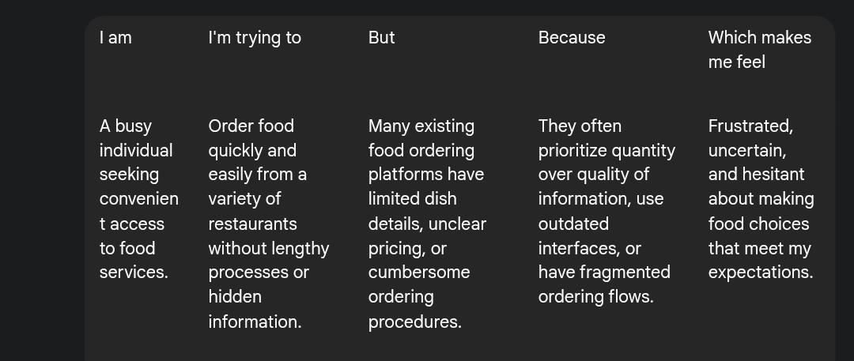

Reference: <https://miro.com/templates/customer-problem-statement/>

| **Problem Statement (PS)** | **I am (Customer)** | **I’m trying to** | **But** | **Because** | **Which makes me feel** |
| --- | --- | --- | --- | --- | --- |
| PS-1 | A food lover who enjoys trying new dishes and cuisines. | Discover interesting meals and order confidently from reliable restaurants. | many platforms lack reliable reviews, photos, or accurate dish | they rely on outdated menus and do not prioritize customer feedback. | disappointed, unsure, and hesitant to try unfamiliar restaurants. |
| PS-2 | a busy professional with a tight schedule. | to order food quickly without wasting time browsing or calling. | many platforms are slow, cluttered, or confusing. | they don’t have streamlined interfaces or quick access to my favorites. | makes me feel irritated, rushed, and less likely to order. |